1: Create Two Pages: One is Home, second one is Add. Create Menu like Navmenu to each page to traverse between two pages. Make it professional, which page is active, hover style.

2: Add Page: A form will be in the page with Email, Name, Mobile, Gender, DoB and Submit Button. Make it professional with CSS, Color change when hover, active, inactive. Create validation for each input field. If any field value is invalid then show error message like figure-2. If all value is valid then store as a line in a file.

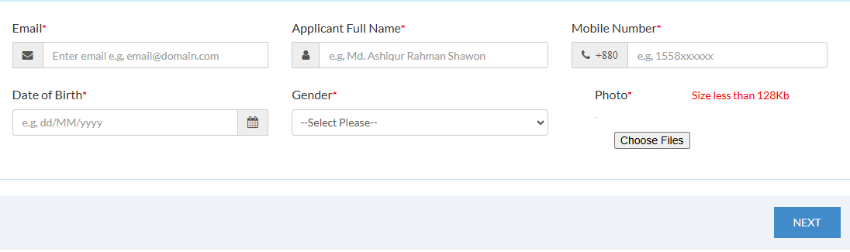

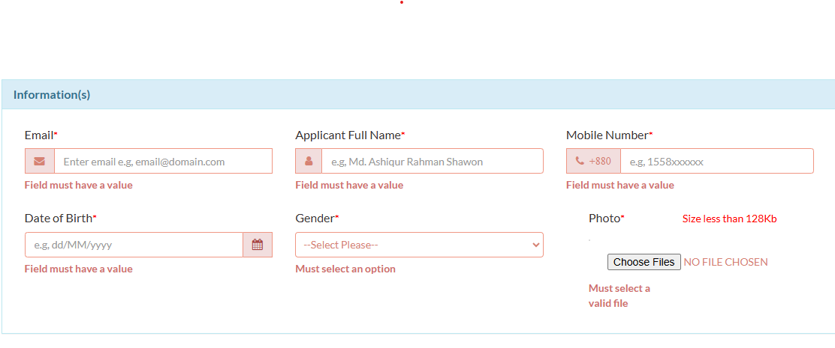

3: In Home page show all lines from file or already declared in variable like a card of each item like image 3. No need to show image, Make Name as Large. Initially 10 applicants’ information will be stored.

